SUBOP Database Abstraction Layer
Report

1.Introduction

1.1.Background
SUBOP (Software United Business Operation Platform) is a database-independent Extract, Transform, Load (ETL) platform designed to simplify data integration across heterogeneous database environments. The platform aims to provide a unified framework that enables organizations to connect multiple data sources, execute ETL pipelines, and transfer data between different database management systems through a common architecture.
One of the primary challenges in modern enterprise data environments is database dependency. Traditional ETL solutions are often tightly coupled to specific database technologies, requiring significant redevelopment effort whenever an organization migrates to a different database platform. In addition, enterprises commonly operate multiple database systems simultaneously, including PostgreSQL, MySQL, Oracle, Microsoft SQL Server, and SQLite, each of which introduces its own SQL dialects, connection mechanisms, data types, and vendor-specific features.
To address these challenges, SUBOP adopts a database-independent architecture based on standardized connectors and a dedicated database abstraction layer. The objective is to allow a single ETL definition to operate consistently across multiple database systems while minimizing database-specific implementation details. By isolating the ETL engine from individual database technologies, the platform seeks to reduce vendor lock-in, improve maintainability, and simplify the integration of new database connectors.
The database abstraction layer is a critical component of the overall SUBOP architecture. It serves as the intermediary between the ETL engine and the underlying database systems, providing a common interface for data access and query execution. However, designing such a layer introduces important architectural trade-offs involving flexibility, implementation complexity, performance, and long-term scalability.
As a result, selecting an appropriate abstraction strategy represents one of the most important design decisions within the SUBOP project. This research investigates multiple abstraction approaches and evaluates their suitability for supporting the database-independent goals of the SUBOP platform.

1.2.Purpose of the Research
Organizations increasingly rely on data originating from multiple heterogeneous systems, including relational databases, cloud platforms, APIs, file-based sources, and real-time event streams. However, existing data integration solutions often suffer from strong dependencies on specific database technologies, resulting in vendor lock-in, duplicated development effort, and increased maintenance costs when database platforms change.
Traditional ETL solutions typically require database-specific configurations, query implementations, and connector logic. As a result, migrating ETL processes from one database system to another frequently requires substantial redevelopment effort. Furthermore, enterprise environments often contain multiple database technologies operating simultaneously, making cross-platform data integration a complex challenge.
SUBOP (Software United Business Operation Platform) is a database-independent data management platform designed to address these challenges by providing an integrated architecture that combines ETL processing, data warehousing, business intelligence, data quality management, and change data capture (CDC) capabilities within a single ecosystem. The platform aims to support multiple database systems through a common abstraction layer while allowing ETL processes to operate independently of the underlying database technology.
A core objective of SUBOP is to enable a single ETL definition to operate across different database management systems with minimal or no code modifications. To achieve this objective, the platform requires a database abstraction layer capable of hiding differences in SQL dialects, data types, connection protocols, and database-specific behaviors. The abstraction layer serves as the foundation for connector interoperability, database portability, and long-term platform scalability.
Because the abstraction layer directly affects connector development, ETL execution, performance, maintainability, and future support for additional database technologies, selecting an appropriate abstraction strategy represents one of the most important architectural decisions within the SUBOP project. This research therefore investigates alternative abstraction approaches and evaluates their suitability for the implementation of the SUBOP database access layer.

1.3.Scope and Objectives
This research focuses on the design and evaluation of database abstraction strategies for the SUBOP platform. The study is limited to the database abstraction layer that operates between the ETL engine and relational database management systems.
The analysis specifically considers support for PostgreSQL, MySQL, Oracle, Microsoft SQL Server, and SQLite, as these systems represent the primary relational database targets for the initial phases of the SUBOP project.
The scope of this research includes:
- Evaluation of alternative database abstraction approaches.
- Analysis of SQL dialect differences across supported databases.
- Assessment of maintainability, extensibility, and implementation complexity.
- Investigation of database portability requirements.
- Recommendation of an architecture suitable for the M4 implementation phase.
The following topics are outside the scope of this research:
- ETL transformation logic and pipeline execution.
- Business Intelligence (BI) components.
- Data Warehouse implementation details.
- Change Data Capture (CDC) mechanisms.
- Frontend and visualization layers.
- Performance benchmarking of production-scale deployments.
Objectives
The primary objective of this research is to identify the most suitable database abstraction strategy for the SUBOP platform.
The specific objectives are:
- To investigate multiple abstraction approaches applicable to the SUBOP architecture.
- To compare the Adapter Pattern, SQLAlchemy Core, and Custom Pipeline DSL approaches.
- To identify major SQL dialect differences among supported database systems.
- To evaluate each approach according to maintainability, extensibility, performance considerations, and implementation effort.
- To determine how database-specific functionality can be managed within a database-independent architecture.
- To provide a justified recommendation for the M4 implementation phase.
- To establish a foundation for future connector development and multi-database support within the SUBOP ecosystem.
The final outcome of this research is a technical recommendation that supports the implementation of a scalable, maintainable, and database-independent abstraction layer for the SUBOP platform.

2.Research Methadology
This research follows a comparative architectural evaluation methodology to identify the most suitable database abstraction strategy for the SUBOP platform. Three alternative approaches were selected based on their relevance to multi-database ETL systems and their applicability to the SUBOP architecture:
- Adapter Pattern
- SQLAlchemy Core
- Custom Pipeline Domain-Specific Language (DSL)
Each approach was analyzed from both a technical and architectural perspective. The evaluation focused on how effectively each solution supports SUBOP's database-independent ETL objectives while maintaining acceptable levels of maintainability, extensibility, and implementation complexity.
The analysis was conducted through literature review, architectural design analysis, technology documentation review, and practical implementation considerations derived from the requirements of the SUBOP abstraction layer.
The results of the evaluation are presented through a structured comparison framework based on predefined evaluation criteria.

2.1.Evaluation Criteria
To ensure a consistent comparison, all candidate approaches were evaluated using the same set of criteria.
Maintainability
The ease with which the abstraction layer can be modified, debugged, and extended over time.
Extensibility
The effort required to support additional database systems, connectors, and future platform capabilities.
Database Independence
The degree to which application logic remains isolated from database-specific implementations and SQL dialect differences.

Implementation Complexity
The estimated development effort, architectural complexity, and learning curve associated with each approach.
Performance Impact
The expected overhead introduced by the abstraction layer compared to native database access.
Scalability
The ability of the solution to support future growth in the number of supported databases and platform features.
Community and Ecosystem Support
The availability of documentation, third-party libraries, industry adoption, and long-term sustainability.
Suitability for SUBOP
The overall alignment of the approach with the objectives, architecture, and development constraints of the SUBOP project.

2.2.Comparison Approach
The comparison was performed by evaluating each abstraction strategy against the predefined evaluation criteria described in Section 2.1.
For each candidate solution, the analysis examined:
- Architectural design and implementation model.
- Advantages and potential benefits.
- Limitations and risks.
- Impact on database portability.
- Impact on future connector development.
- Compatibility with the SUBOP platform architecture.
The three approaches were then compared qualitatively using a decision matrix. Rather than focusing solely on technical capabilities, the evaluation also considered practical project constraints such as implementation effort, maintainability, expected project timeline, and long-term platform sustainability.
The outcome of this comparison forms the basis for the final recommendation presented in last section.

3.Option A- Adapter Pattern

3.1.Architecture Overview
The Adapter Pattern introduces an intermediate abstraction layer between the ETL engine and individual database systems. A common BaseConnector interface defines the operations required by the ETL engine, while each database system provides its own adapter implementation.
Following diagram illustrates the high-level architecture of the Adapter Pattern within the context of the SUBOP abstraction layer.
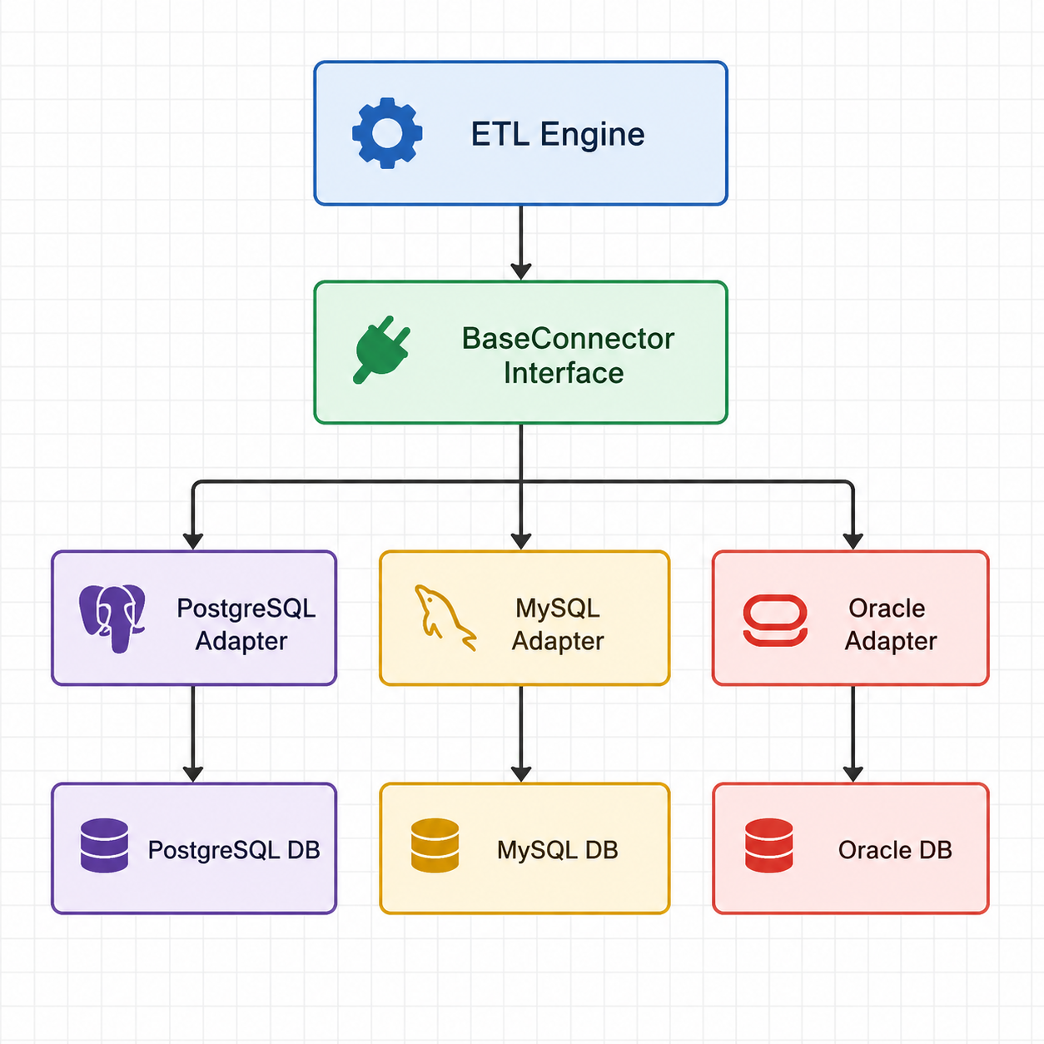
In this architecture, the ETL engine interacts exclusively with the BaseConnector interface and remains unaware of database-specific implementation details. Database adapters are responsible for translating generic operations into database-specific queries, connection handling procedures, and data type mappings.
This approach promotes separation of concerns by isolating database-specific logic within dedicated adapter classes. As a result, support for new database systems can be added by implementing additional adapters without modifying the ETL engine itself.

3.2.Advantages
The Adapter Pattern offers several advantages for a database-independent ETL platform such as SUBOP.
Clear Separation of Concerns
Database-specific logic is isolated within dedicated adapter implementations. The ETL engine interacts only with the common BaseConnector interface, reducing coupling between business logic and database technologies.
Improved Maintainability
Changes to a particular database implementation can be made within the corresponding adapter without affecting the rest of the system. This simplifies maintenance and reduces the risk of introducing unintended side effects.
Extensibility
New database systems can be supported by implementing additional adapters that conform to the BaseConnector interface. Existing ETL functionality can remain unchanged while platform capabilities continue to grow.
Technology Independence
The architecture does not rely on external abstraction frameworks or ORM solutions. This provides full control over the implementation and allows database-specific optimizations when required.
Consistent Development Model
All database connectors follow the same architectural pattern and interface contract. This promotes code consistency and simplifies future connector development.
Alignment with SUBOP Objectives
The Adapter Pattern directly supports SUBOP's goal of reducing database dependency by providing a common access layer between the ETL engine and multiple database systems. The architecture also aligns well with the project's planned connector-based ecosystem and plugin-oriented design.

3.3.Disadvantages
Despite its architectural simplicity, the Adapter Pattern also introduces several limitations that must be considered when designing a database-independent platform such as SUBOP.
Manual SQL Dialect Management
Each database system implements SQL differently. Query syntax, functions, pagination mechanisms, and vendor-specific features must be handled manually within individual adapters. As the number of supported databases increases, managing these differences becomes increasingly complex.
Increased Development Effort
Every supported database requires its own adapter implementation and maintenance. Common functionality often needs to be reimplemented across multiple adapters, resulting in additional development effort.
Scalability Challenges
As more database systems are added, the number of adapter implementations grows accordingly. This may increase maintenance costs and make long-term platform evolution more difficult.
Feature Duplication
Database-specific capabilities often require additional methods or custom implementations within each adapter. As a result, similar functionality may be duplicated across multiple database connectors.
Higher Testing Requirements
Since each adapter contains database-specific logic, comprehensive testing must be performed for every supported database system. This increases the overall testing effort and complexity of quality assurance processes.
Limited Abstraction of Database Differences
While the Adapter Pattern provides a common interface, it does not automatically resolve SQL dialect differences, data type mappings, or vendor-specific behaviors. These challenges remain the responsibility of the adapter implementations and may become significant as the platform expands.

